Zero Copy Cloning

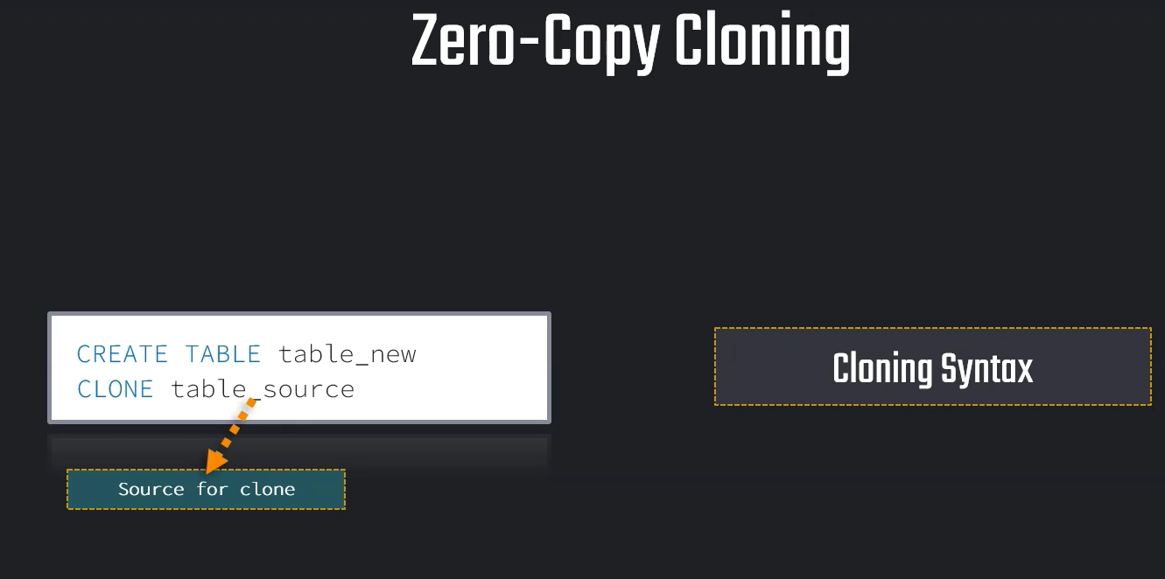
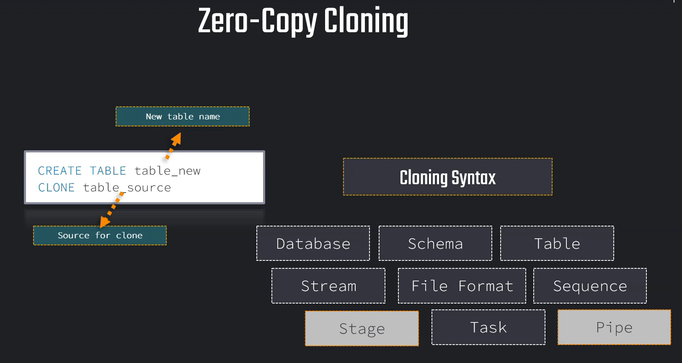

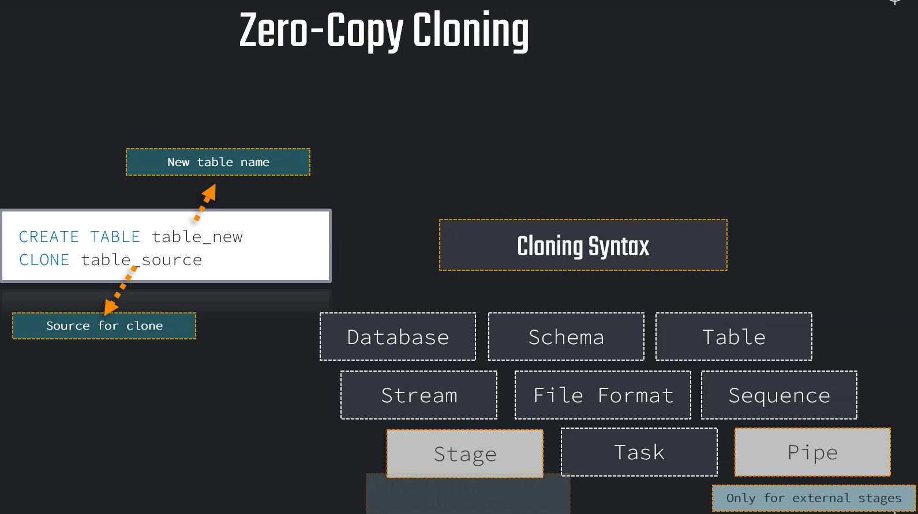

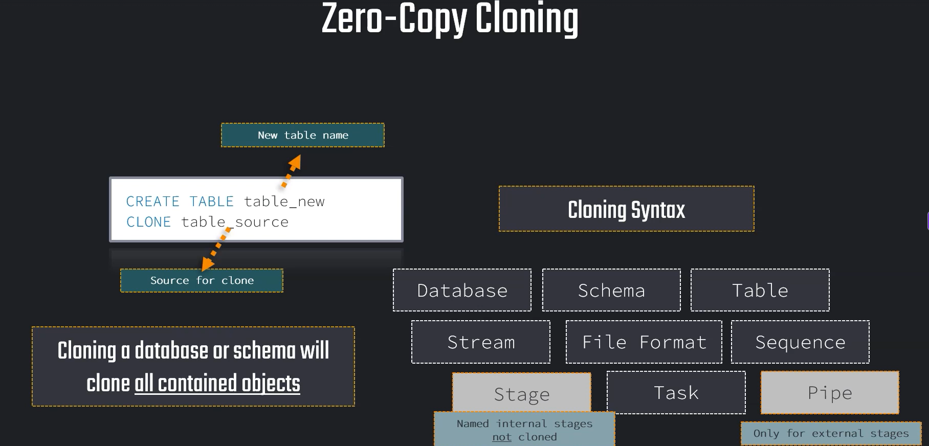

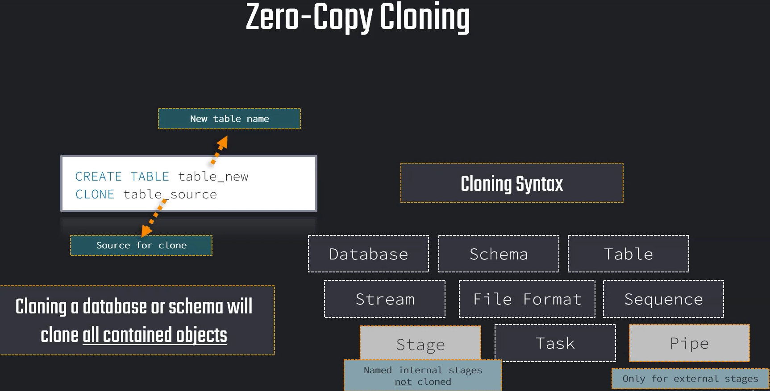

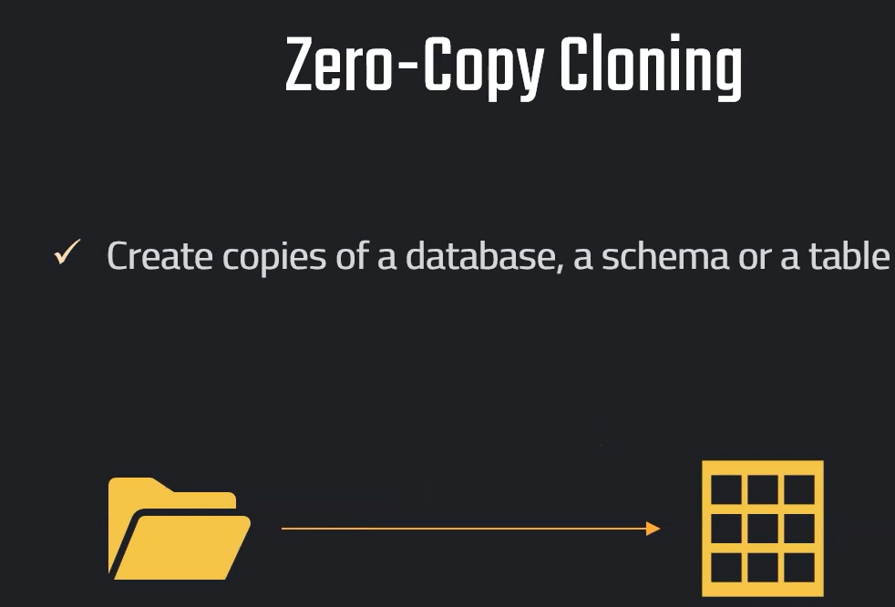

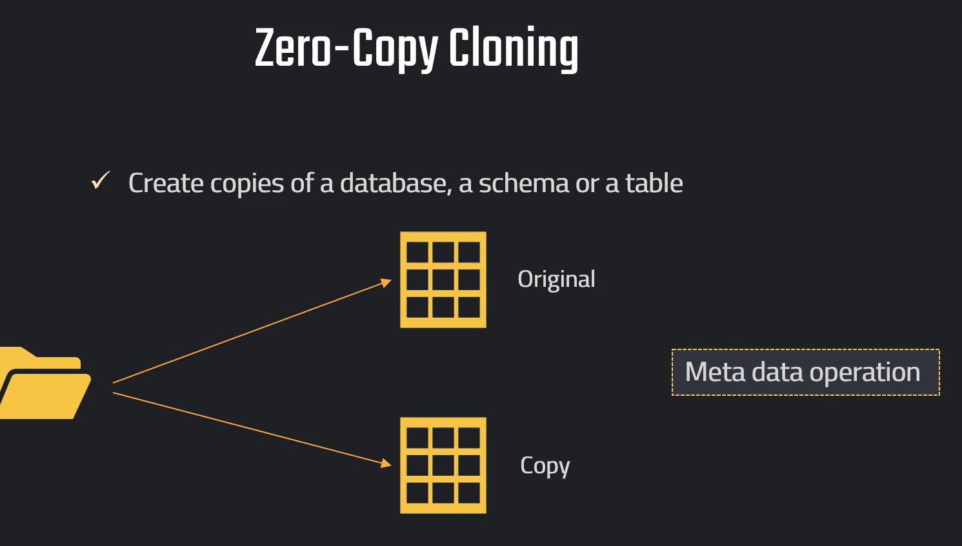

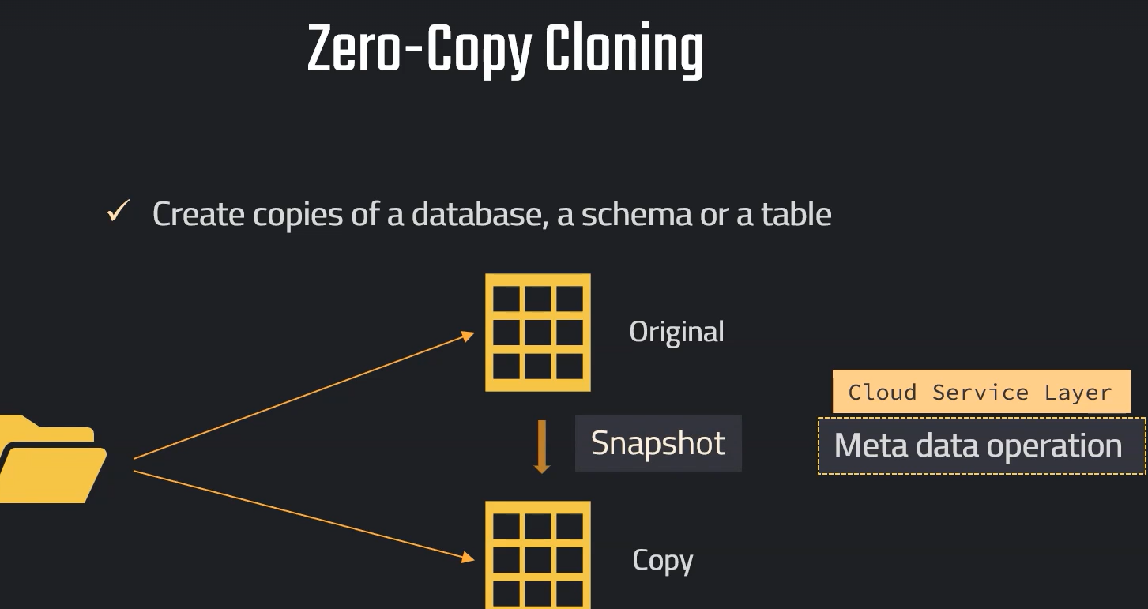

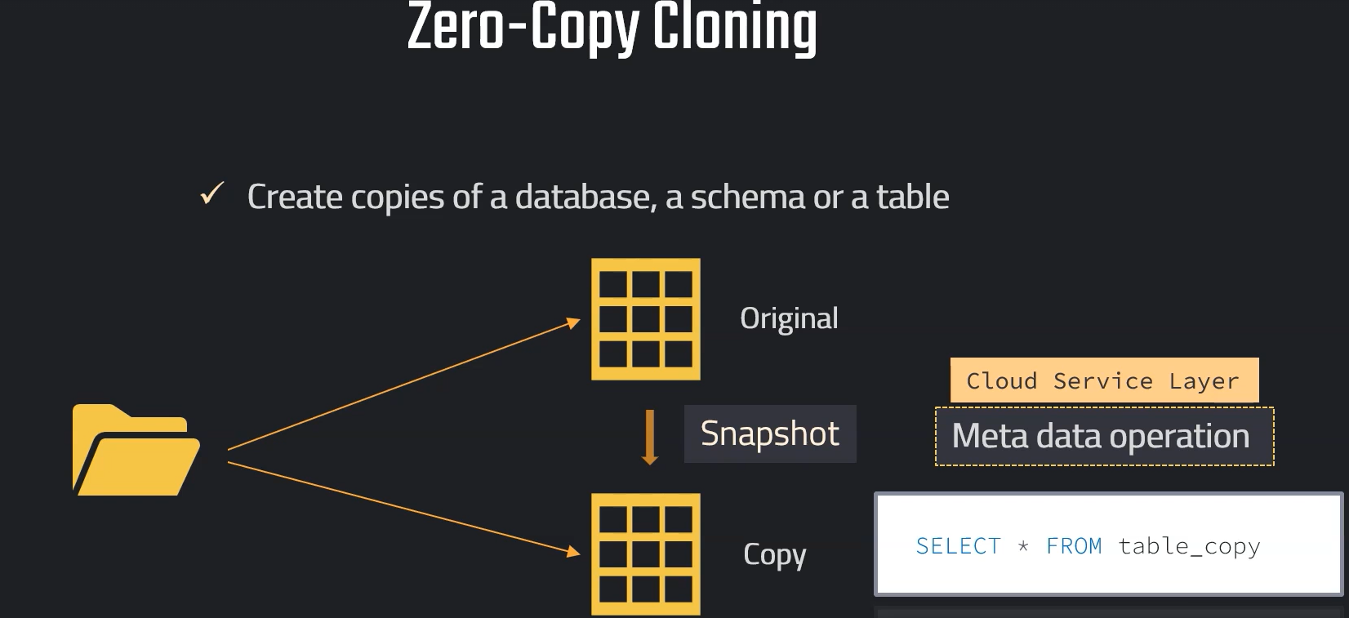
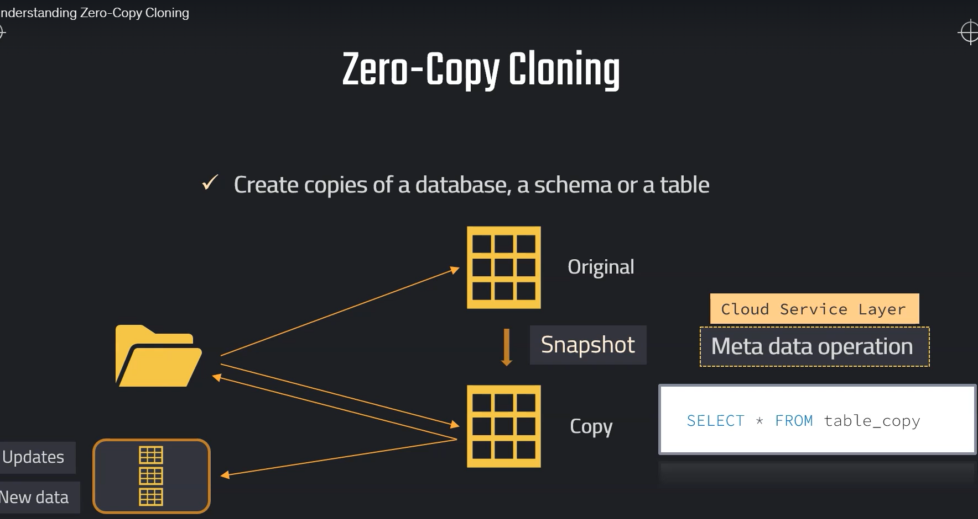

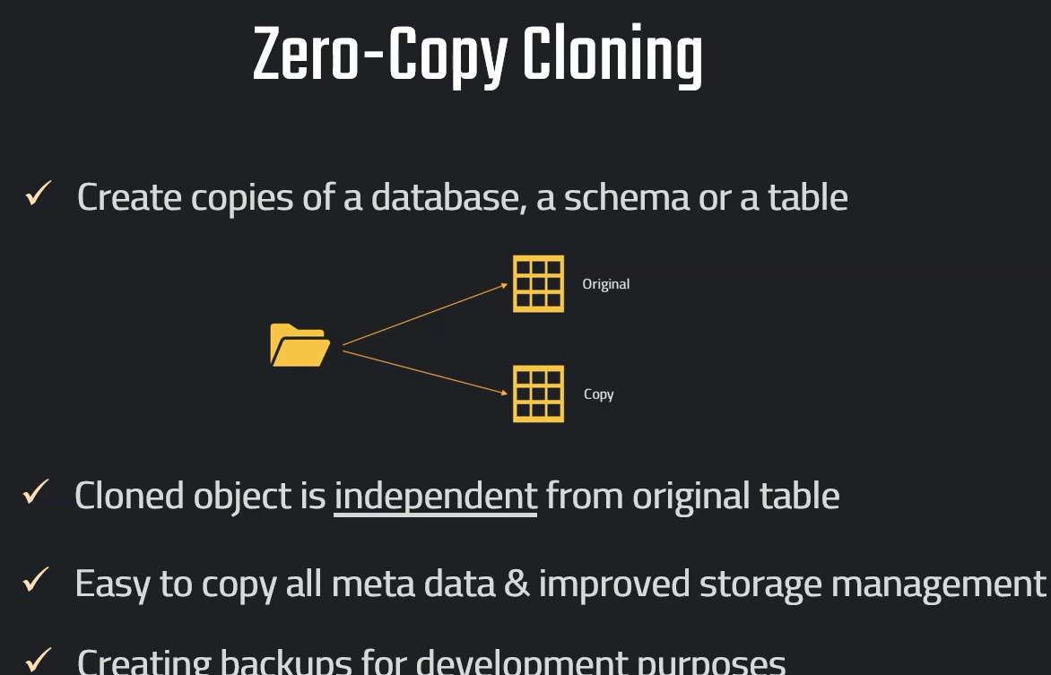

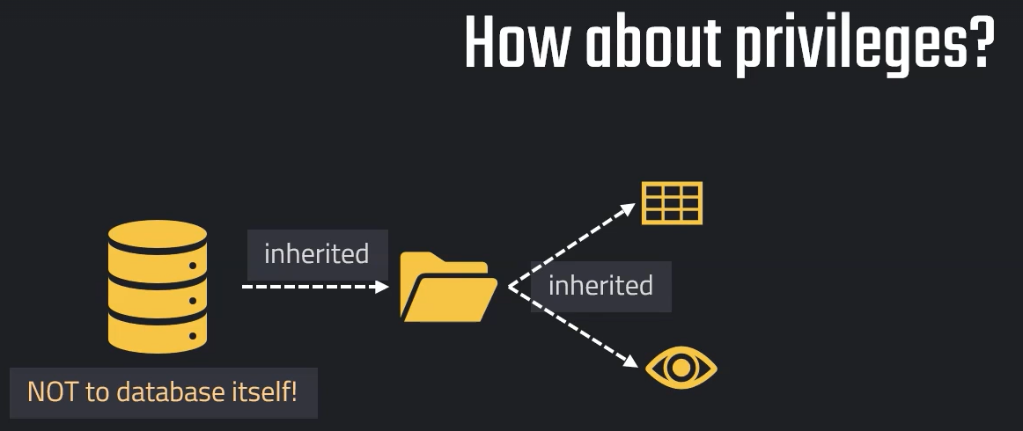

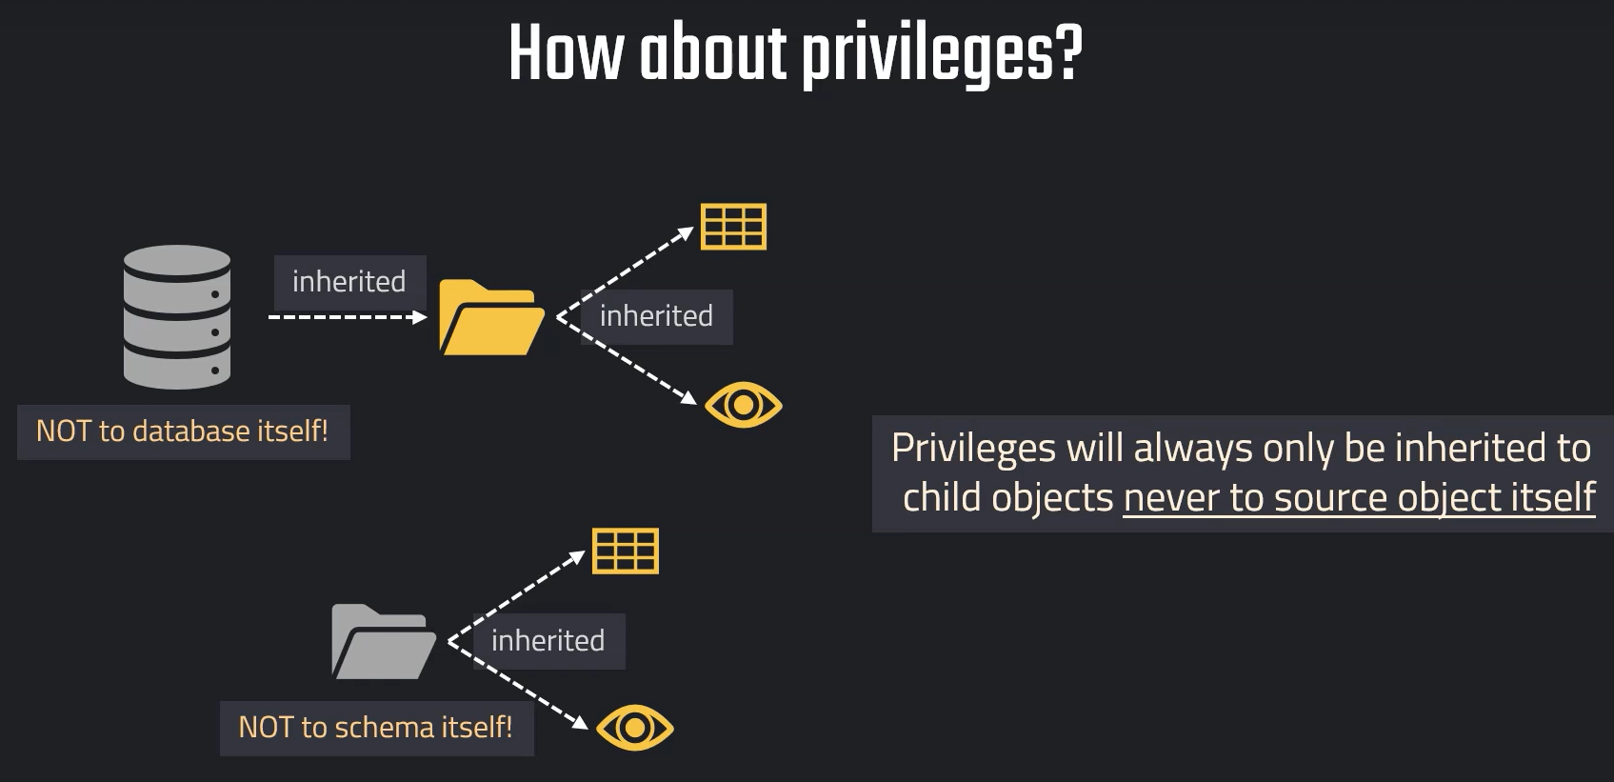

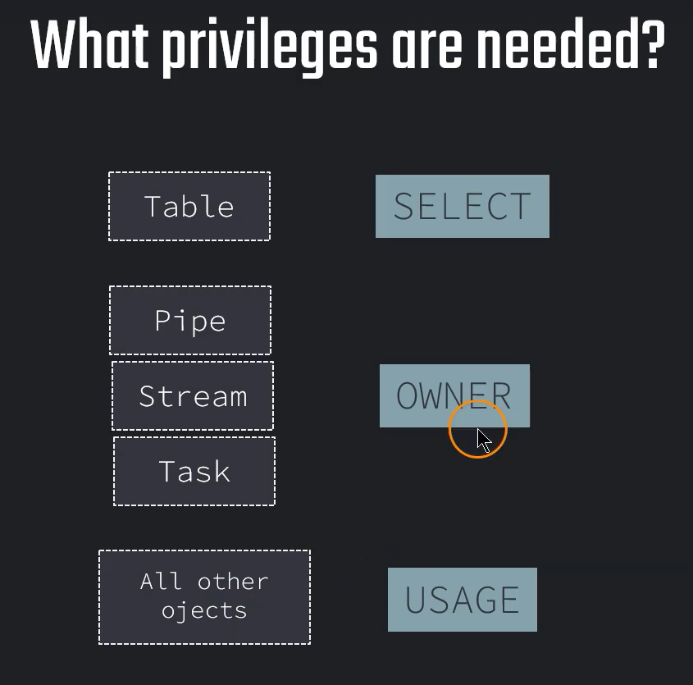

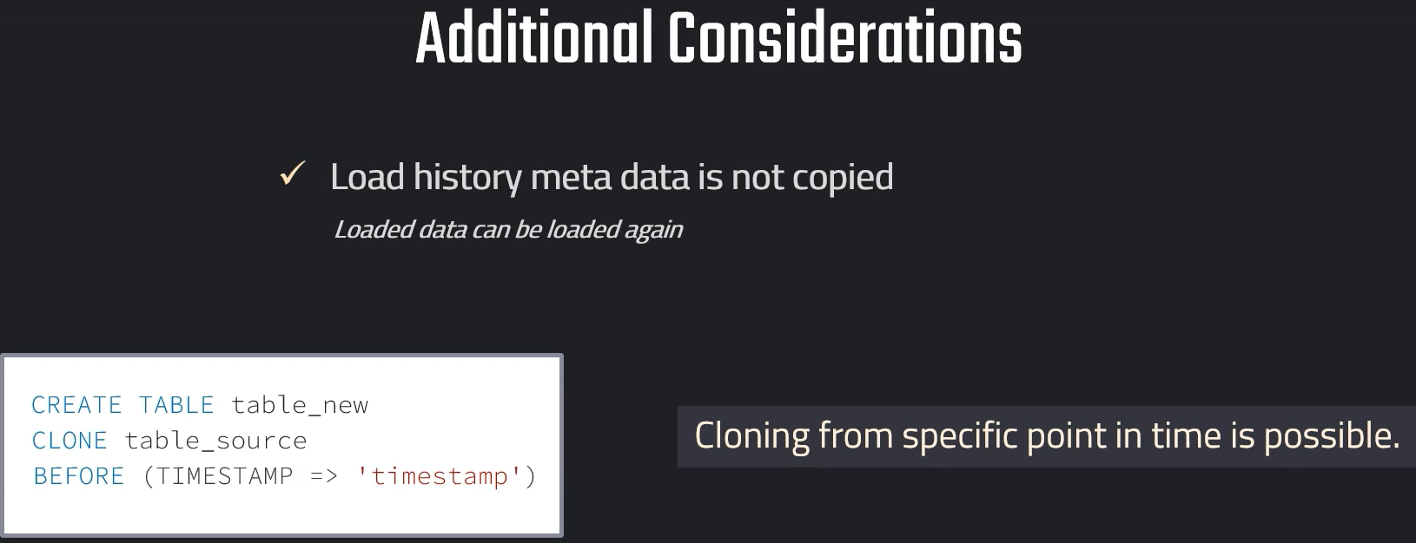

// Cloning

SELECT * FROM OUR_FIRST_DB.PUBLIC.CUSTOMERS;

CREATE TABLE OUR_FIRST_DB.PUBLIC.CUSTOMERS_CLONE
CLONE OUR_FIRST_DB.PUBLIC.CUSTOMERS;

// Validate the data
SELECT * FROM OUR_FIRST_DB.PUBLIC.CUSTOMERS_CLONE;

// Update cloned table

UPDATE OUR_FIRST_DB.public.CUSTOMERS_CLONE
SET LAST_NAME = NULL;

SELECT * FROM OUR_FIRST_DB.PUBLIC.CUSTOMERS ;

SELECT * FROM OUR_FIRST_DB.PUBLIC.CUSTOMERS_CLONE;

// Cloning a temporary table is not possible
CREATE OR REPLACE TEMPORARY TABLE OUR_FIRST_DB.PUBLIC.TEMP_TABLE(
id int);

CREATE TEMPORARY TABLE OUR_FIRST_DB.PUBLIC.TABLE_COPY
CLONE OUR_FIRST_DB.PUBLIC.TEMP_TABLE;

SELECT * FROM OUR_FIRST_DB.PUBLIC.TABLE_COPY;

Cloning with Time Travel

// Cloning using time travel

// Setting up table

CREATE OR REPLACE TABLE OUR_FIRST_DB.public.time_travel (
id int,
first_name string,
last_name string,
email string,
gender string,
Job string,
Phone string);

CREATE OR REPLACE FILE FORMAT MANAGE_DB.file_formats.csv_file
type = csv
field_delimiter = ','
skip_header = 1;

CREATE OR REPLACE STAGE MANAGE_DB.external_stages.time_travel_stage
URL = 's3://data-snowflake-fundamentals/time-travel/'
file_format = MANAGE_DB.file_formats.csv_file;

LIST @MANAGE_DB.external_stages.time_travel_stage;

COPY INTO OUR_FIRST_DB.public.time_travel
from @MANAGE_DB.external_stages.time_travel_stage
files = ('customers.csv');

SELECT * FROM OUR_FIRST_DB.public.time_travel;

// Update data

UPDATE OUR_FIRST_DB.public.time_travel
SET FIRST_NAME = 'Frank' ;

// Using time travel
SELECT * FROM OUR_FIRST_DB.public.time_travel at (OFFSET => -60*1);

// Using time travel
CREATE OR REPLACE TABLE OUR_FIRST_DB.PUBLIC.time_travel_clone
CLONE OUR_FIRST_DB.public.time_travel at (OFFSET => -60*1.5);

SELECT * FROM OUR_FIRST_DB.PUBLIC.time_travel_clone;

// Update data again

UPDATE OUR_FIRST_DB.public.time_travel_clone
SET JOB = 'Snowflake Analyst' ;

// Using time travel: Method 2 - before Query
SELECT * FROM OUR_FIRST_DB.public.time_travel_clone before (statement => '<your-query-id>);

CREATE OR REPLACE TABLE OUR_FIRST_DB.PUBLIC.time_travel_clone_of_clone
CLONE OUR_FIRST_DB.public.time_travel_clone before (statement => '<your-query-id>');

SELECT * FROM OUR_FIRST_DB.public.time_travel_clone_of_clone ;

//swapping Table

//// Swapping tables

// Setting up dev table
CREATE TRANSIENT SCHEMA OUR_FIRST_DB.COPIED_SCHEMA
CLONE OUR_FIRST_DB.PUBLIC;

SELECT * FROM OUR_FIRST_DB.COPIED_SCHEMA.CUSTOMERS
SELECT * FROM OUR_FIRST_DB.PUBLIC.CUSTOMERS

// Modifying "Dev Table"
DELETE FROM OUR_FIRST_DB.COPIED_SCHEMA.CUSTOMERS WHERE ID < 500

SELECT * FROM OUR_FIRST_DB.COPIED_SCHEMA.CUSTOMERS
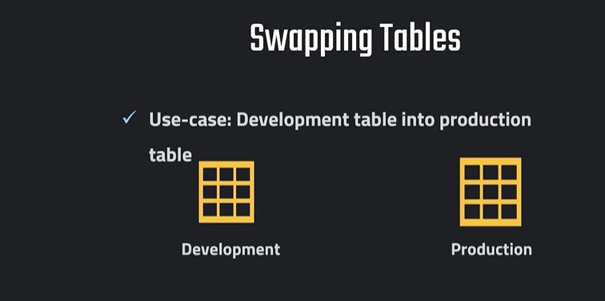

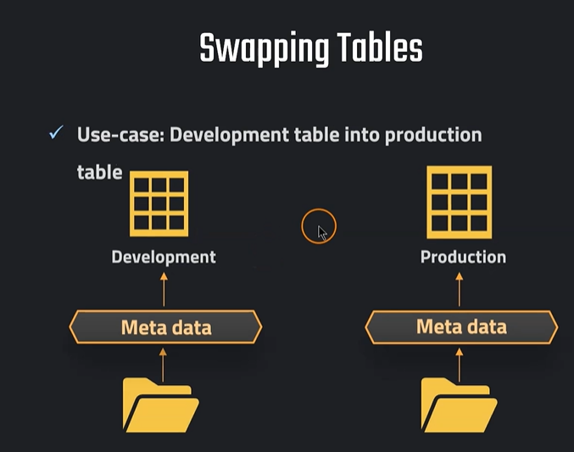

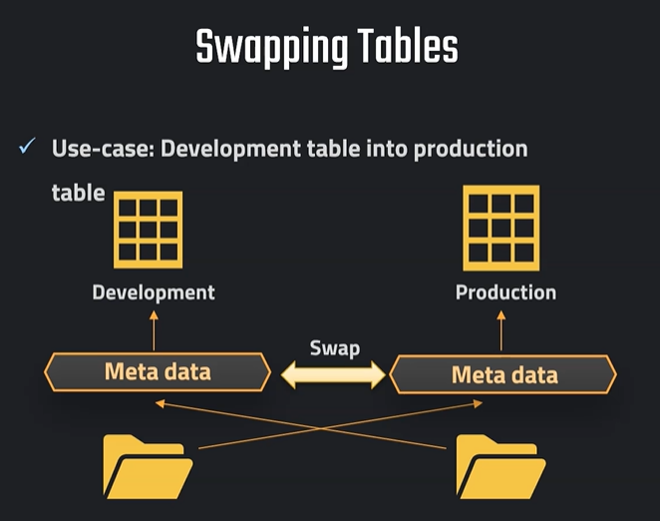
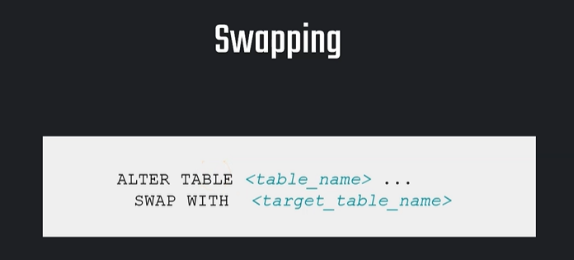

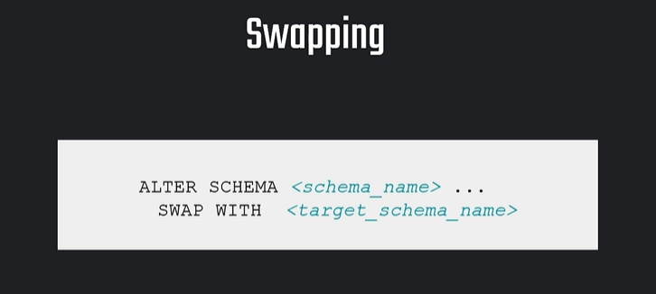
// Swapping Tables
ALTER TABLE OUR_FIRST_DB.COPIED_SCHEMA.CUSTOMERS
SWAP WITH OUR_FIRST_DB.PUBLIC.CUSTOMERS

// Verifying results
SELECT * FROM OUR_FIRST_DB.COPIED_SCHEMA.CUSTOMERS
SELECT * FROM OUR_FIRST_DB.PUBLIC.CUSTOMERS

